**Abstract**

The face is one of the easiest ways to distinguish the individual identity of each other. Face recognition is a personal identification system that uses personal characteristics of a person to identify the person's identity. Human face recognition procedure basically consists of two phases, namely face detection, where this process takes place very rapidly in humans, except under conditions where the object is located at a short distance away, the next is the introduction, which recognize a face as individuals. In our proposed approach, firstly, video framing is performed by activating the camera through a user-friendly interface. The face is detected and segmented from the video frame by using Local Binary Patterns algorithm and haar cascade classifier. In the pre-processing stage, scaling of the size of images is performed, if necessary, in order to prevent loss of information. The median filtering is applied to remove noise followed by conversion of color images to grayscale images. The program has a GUI application which help in the user-friendly use consisting of training the system, detecting the face and generating the data.

**Introduction**

Face is one of the most important biometric features of a human. A human can recognize different faces without difficulty. It is a task that is trivially performed by humans, even under varying light and when faces are changed by age or obstructed with accessories and facial hair. Nevertheless, it had remained a challenging computer vision problem for decades until recently. With the advancement of technology and growing use of computers in our daily life, it is essential to develop systems that can precisely detect and recognize human faces. We aim to propose an approach that can achieve the desired goal of face detection and identification effectively.

**1.1: Background**

Face recognition is crucial in daily life in order to identify family, friends or someone we are familiar with. Human intelligence allows us to receive information and interpret the information in the recognition process. We receive information through the image projected into our eyes in the form of light. Light is a form of electromagnetic waves which are radiated from a source onto an object and projected to human vision processing done. By the human visual system. The analyzed information will be compared to other representation of objects or face that exist in our memory to recognize. However, it is hard challenge to build an automated system to have the same capability as human to recognize faces. In order to overcome human limitations, computers with almost limitless memory, high processing speed and power are used in face recognition systems.

The human face is a unique representation of individual identity. Thus, face recognition is defined as a biometric method in which identification of individual is performed by comparing real time capture image with stored images in the database of that person. The work on face recognition began in 1960.Woody Bledsoe, Helen Chan Wolf and Charles Bisson had introduced a system which required the administrator to locate eyes, ears, nose and mouth from images. The distance and ratios between the located features and the common reference points are then calculated and compared. The studies are further enhanced by Goldstein, Harmon and Leskin 1970 by using other features such as hair color and lip thickness to automate the recognition. It wasn’t until the late 1980s that we saw further progress with the development of Facial Recognition software as a viable biometric for businesses. In 1988, Kirby and Silovich first suggested principle component analysis (PCA) to solve face recognition problem. A system that came to be known as Eigenface showed that feature analysis on a collection of facial images could form a set of basic features. They were also able to show that less than one hundred values were required in order to accurately code a normalized facial image. In 1991, Turk and Pentland carried on the work of Sirovich and Kirby by discovering how to detect faces within an image which led to the earliest instances of automatic facial recognition. This significant breakthrough was hindered by technological and environmental factors, however it paved the way for future developments in Facial Recognition technology.

Better and more novel approaches than Kohonen approach for facial recognition using; Principal Component Analysis (PCA), Fisherfaces and the traditional Local Binary Patterns (LBP) were proposed, particularly the LBP, because it has a simple theory with computational simplicity, invariant with respect to any monotonic transformation of gray scale, has powerful rotation-invariant analysis with a uniform pattern and discriminates excellently between different various kinds of texture. But it is known that the LBP is not as robust as the viola-jones and other algorithms for face detection because of issues such as noise, illumination variation, background, pose, scale and occlusion etc.

Recently, different methods, techniques and algorithms were combined with either the traditional LBP or modified LBP to achieve facial recognition and enhance facial recognition accuracy. In Real-Time Multiple Face Recognition using Deep Learning on Embedded GPU System was proposed and the method used face detection based on convolutional neural network (CNN) with face tracking and state of the art deep CNN face recognition algorithm. In addition, a Local Binary Pattern Histogram (LBPH)-based Enhanced Real-Time Face Recognition was used to achieve real-time face recognition in low and high-level images.

Later on different algorithm were proposed such as Fisherfaces(1997), Scale Invariant Feature Transform (SIFT) (1999) ,published by David Lowe in 1999, Speed Up Robust Features (SURF) (2006), published by Herbert Bay, Tinne Tuytelaars, and Luc Van Gool. Many studies on the face recognition were then conducted continuously until today (Ashley Duval, 2012).

**1.2: Problem statement**

The problem of face recognition can be stated as identifying as individual from others in a set of given images. There are many factors that leads to variations in the images of a single face which add to the complexity of recognizing faces accurately. Some of them can be listed as follows:

* **Presence or absence of structural components**

Facial features such as beards, mustaches, and glasses may or may not be present and there is a great deal of variability among these components including shape, color and size.

* **Pose**

The images of a face vary due to the relative camera-face pose (frontal, tilted, profile, upside down).

* **Occlusion**

Faces may be partially occluded by other objects. For an example, in an image with a group of people, some faces may partially occlude other faces (face identification).

* **Image orientation**

Face images directly vary for different rotations about the camera’s optical axis.

* **Imaging conditions**

When the image is formed, factors such as lightning and camera characteristics affect the appearance of a face.

* **Age**

Images taken after one- or two-year’s gap may not match with the images in database.

**1.3: Objectives**

Our objective is to make a system that will use computer vision techniques to automatically detect and identify faces from the digital images which are extracted from the input video. The identification and recognition is based on prominent facial features such as region of the eyes, face shape etc. The main objectives of the program are discussed below:

* To build a fast and efficient face recognition system that detects faces very quickly in cluttered backgrounds.
* To detect the face segment from the video frame.
* To train our system with sufficient images.
* To extract the useful features from the face detected.
* With these feature vectors we wish to label the target images using SVM classification.
* We aim to compare various recognition techniques and present a tradeoff between accuracy and speed for each of them.

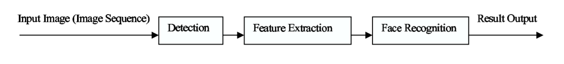

Fig 1.3: The basic flowchart of a face recognition

**1.4: Application areas**

Face recognition has its applicability in various fields. It is used for two primary tasks:

1. **Verification (one-to-one matching)**

When presented with a face image of an unknown individual along with a claim of identity, ascertaining whether the individual is who he/she claims to be.

1. **Identification (one-to-many matching)**

Given an image of an unknown individual, determining that person’s identity by comparing (possibly after encoding) that image with a database of (possibly encoded) images of known individuals.

There are numerous application areas in which face recognition can be exploited for these two purposes, a few of which are outlined below:

1. **Surveillance**

A large number of CCTVs can be used monitor to look for known criminals, drug offenders, etc. and authorities can be notified when one is located.

1. **General identity verification**

Electoral registration, banking, electronic commerce, identifying newborns, national IDs, passports, drivers’ licenses, employee IDs

1. **Image database investigations**

Searching image databases of licensed drivers, benefit recipients, missing children, immigrants and police bookings.

1. **Attendance system**

Identifying the students, employees, staff institutional presence in the faculty for working data.

1. **Security**

Access control to buildings, airports/seaports, ATM machines and border checkpoints, computer/ network security email authentication on multimedia workstations.

**1.5: project features**

Facial recognition being a biometric based technique involves processing of biological aspect. So, the features of such system also revolve around the facial processing such as:

* **Trainer**

Takes all the user facial data from the camera to train the program to recognize the face with OpenCV recognizer.

* **Database**

Stores all the pictorial data which is then used for detection and recognition process.

* **Face detection**

Allows the system to accurately detect the face of the person even in clustered background.

* **Face recognition**

Identifies the person with the data stored in the data base in real time and displays the name.

* **GUI system**

Visual design of the program into application for easy use for all users.

**Methodology**

The proposed face recognition approach has four main steps: module for image acquisition, module for extraction, features, module for training classifier database, and module for classification. Initially, the face datasets are collected by the image acquisition module. Then, a series of salient features are extracted by applying feature extraction module. These facial features are used to analyze face landmarks which represent human identity information. In the next process, the classifier is trained for recognizing the face. In the last module, the system recognize face image and fetch information about the person from the SQLite database. The system flow chart is shown in Figure. 4

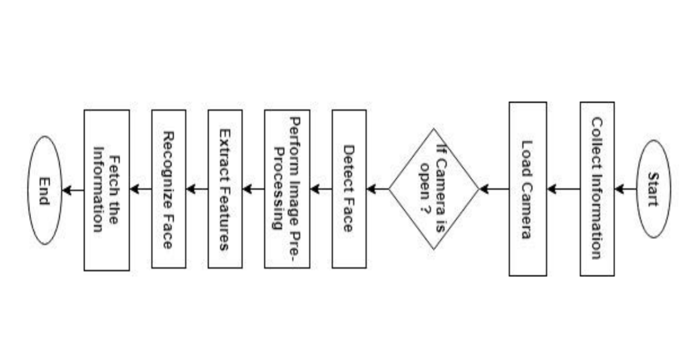

Fig 3: Face recognition system workflow

**3.1 Face Detection**

For face detection, OpenCV is used that introduces a Haar cascade classifier .Initially, it takes an input image using the camera and converts that color image into a grayscale image. After this, it loads Haar cascade classifier for determining whether the image contains any faces in the frame or not. When any face is detected, other facial features are checked and a square frame is drawn on the face. Otherwise, it starts reading other pictures. Figure 3.1 shows the flow chart of the detection process.

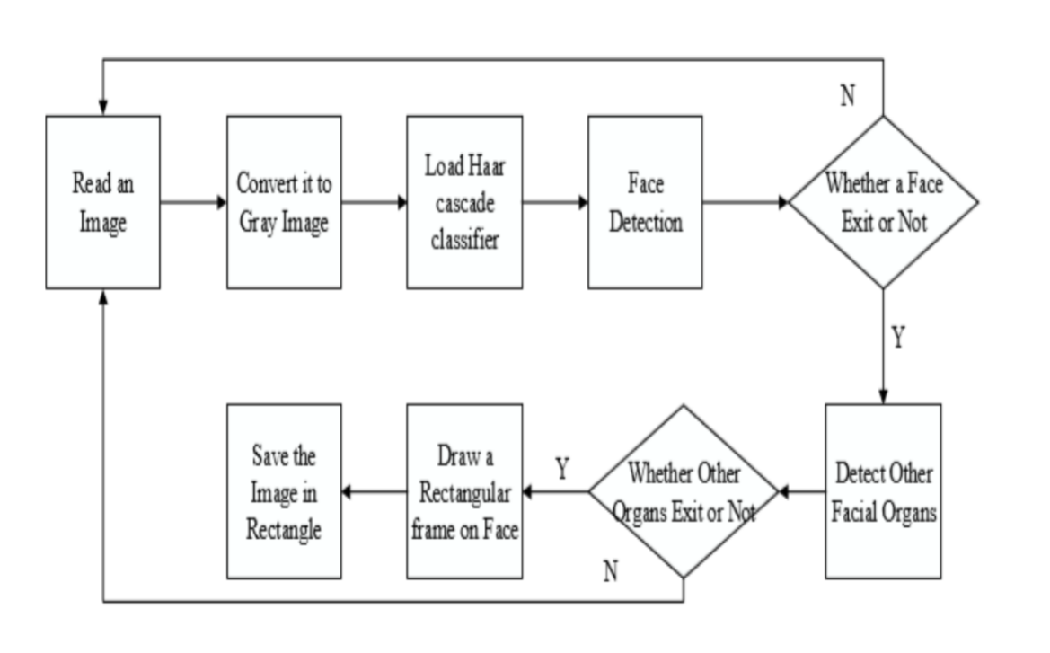

Fig 3.1: Face detection flow chart

**3.2 Feature Extraction**

For extracting the facial features from image, the LBP operation is used that compares the intensity value of every component with the 8 nearest neighbor pixels values. If the value of the neighboring pixel is greater than the value of the centered pixel, it will assign 1 to its neighboring pixel, otherwise it will assign 0. For each pixel, this task provides an 8-bit string. A decimal value of an 8-bit pixel string determines the LBP value. Fig. 3.2 shows this operation.

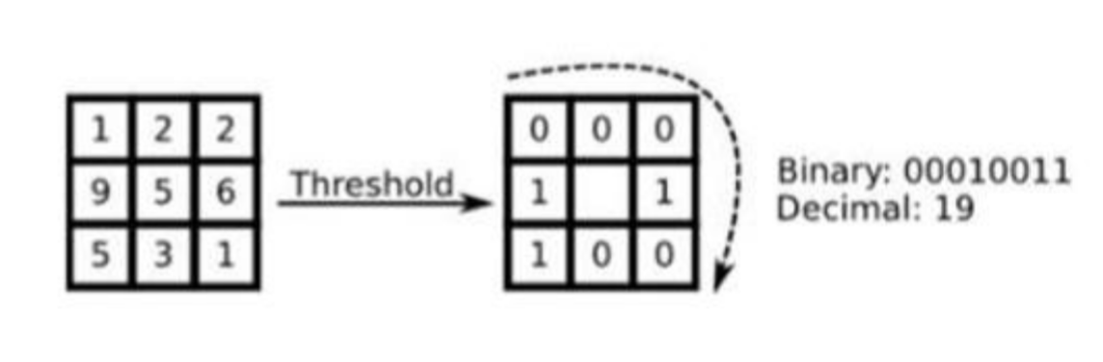

Fig3.2: Extraction of LBP feature from the image

The input image is divided into many small sub-images after the application of the LBP operation and the histograms of the LBP value of each sub-images are extracted. Then all histograms are linked to make an image-representing feature vector and used to train a facial recognition classifier.

**3.3 Dataset**

We designed our own dataset, with 200 individual photos. Throughout the image acquisition process, face images are cropped and converted into gray images, then these images are saved in the same folder to make face databases for extraction tasks. After this, the standardization technique is applied to all images to reduce noise and set the correct image scaling position to quickly obtain the result of recognition. Dataset images are shown in Figure 3.3

   

Fig 3.3: Dataset images

**3.4 Face Recognition**

For the face recognition process, Local Binary Pattern Histogram algorithm is applied. The LBP operator uses local binary patterns to reduce the local spatial distribution of a face image. The LBP operator is a collection of binary pixel value ratios in the center at regular pixel intervals and is around 8 pixels. It is shown in the below equation.

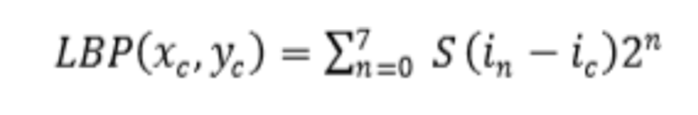

Where ic represents the index value of the middle pixel and (xc, yc) shows 8 close surrounding pixels data.

**3.5 GUI system**

The final product of the program is then converted into a graphical interface system, .exe file which makes it user friendly to use. This helps in running all the function of the program in the same window and covers all the codes of the program.

Epilogue

4.1 Expected output

To develop a face recognition system, first we have to prepare the face dataset for training. To develop face dataset, we used Face detection method that detects the face in real time camera and captured face images. That captured images are saved into dataset folder for feature extraction and training processes. In the initial phase, system asks information about the person like name, age, gender and then the camera will open that captures 200 images of a person on different face position and expression. The information about person is saved into SQLite database and captured images are saved into dataset folder with same unique id. In the next process, the system extracts the LBP texture features from every input dataset image and train them with the Haar Cascade classifier. Finally, the system performs face recognition process. So the expected output can be seen as in the figure below:

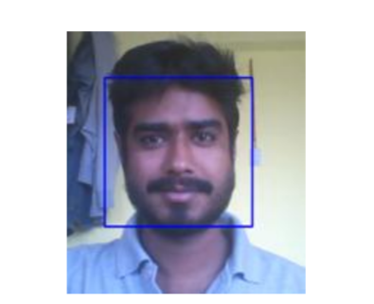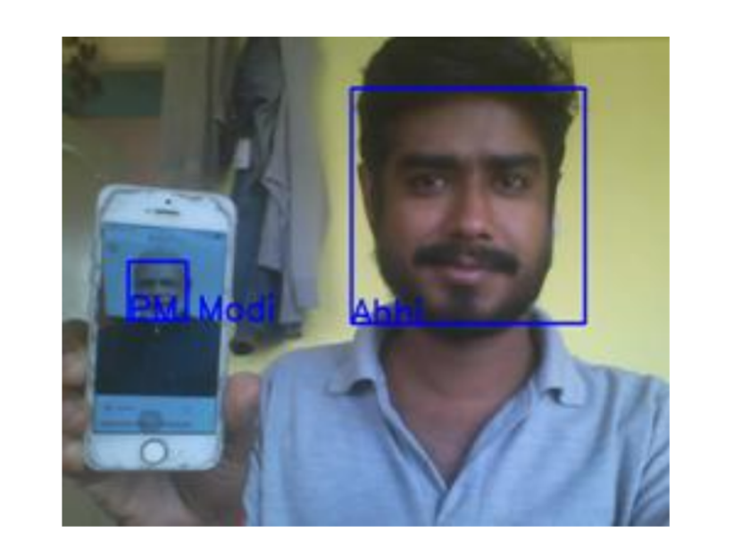

Fig 4.1 Face Detection Fig 4.1.1Face Recognition

4.2 Working schedule